Project: INTEGRATED THERAPEUTIC ARTS AND SOCIAL EMOTIONAL LEARNING FOR CHILDREN AND YOUTHS IN ZONE 1 BIDIBIDI REFUGEE SETTLEMENT
Project goal: Reduced suffering and improved mental health and psychosocial well-being among 40 children below the age of 18 and 70 youths between 18-25years,10 teachers and 10 community-based para counselors in Zone 1-Twajiji Village Bidi bidi Refugee Settlement Northern Uganda
Reporting period | June 2023
Compiled by: | Owino Paul |  |  | Reviewed by: |  |  | Mukasa Moses
Submitted To Donor | Global Alliance for Africa
Target: Children and youths, School teachers and Para counsellors |  |  |  |  |  |  |  |  | Project location: Twajiji Village,Bidibidi Settlement Northern Uganda
Summary of Project background:
Uganda hosts up to 41% of the 2.3 million people displaced by South Sudan’s long-running civil war with at least 272,206 hosted in the Bidi bidi refugee settlement. children make 68% of the total population according to (Source OPM RIMs). This settlement is subdivided into 5 zones of 1,2,3,4 & 5 with most of the refugees originating from South Sudan. Displacement has cut short the education of many, restricted their livelihood options, and uprooted them from traditional socio-cultural roles in their communities. Youth, accordingly, suffer from inexperience and disillusionment to which high suicide rates are a testament. UNHCR (2021) reports accentuate that 65% of children in Bidi bidi have experienced physical violence 15% reported emotional violence well as 96% of both children and adults self-reported the existence of distress among children. (35%) attributed it to lack of food, 23% to separation from families, (38%) to staying in a bushy environment and restriction to play in one area and lack of play items. With youth and distressed children opt for negative coping strategies such as alcoholism and substance abuse, engaging in violent and gang fights, stealing and robbery, and early marriages among others. Through this project, TWSB promotes and strengthen capacities within the community through a GAA adapted therapeutic arts in its community based psychosocial support work to promote coping and psychosocial wellbeing including through outcomes and processes associated with social emotional learning framework (SEL) being implemented in target with children, youths, teachers and community-based para-counsellors within zone 1 of Bidibidi refugee settlement.

Planned project activities in the month (Coded as in the Work plan) |  | Target: (As in W/P) | Achieved |  | Cumulative | Variance |  | Comments on the results (under/over achievement), process and possible outcomes
Result/objective 1100: Social-emotional learning and psychosocial well-being of children and youths are improved through integrated therapeutic arts and community based psychosocial
Obj/Phase 1(TBD)- |  | Increased awareness and visibility of the project goal, objectives, and envisioned outcomes through organized inception meetings, workshops, and presentations in the online MHPSS working group meetings both national and onsite
1111 – Participatory Project inception meetings are organized with the participation of school headteachers, community leaders, Office of the Prime minister, and other duty bearers  Presentation of the project goals and objectives are presented in the settlement and national MHPSS working group meetings |  | 25 (14-M, 11-F) persons including government representatives attached to Bidi-bidi refugee settlement under the office of the prime minster, UNHCR, District, local leaders, community school management committees, teachers and partner staffs were reached during the project inception meeting.  These were introduced to the fund source, given in-depth contribution of the project to the targeted beneficiaries and the impact it would have on them, their families, and communities.  A lot of positive feedback including that which highlighted the importance of the project in addressing the intersecting mental health vulnerabilities with education, child and youth related experiences of violence and abuse but also leaders highlighted the importance of the project in a sense that it will strengthen the capacity of their teachers and fellow community members to support their children and the youths within zone 1.  Office of the prime minister stressed a huge token of appreciation on the consideration of the Psychosocial Wellbeing of not only school going children but also their teachers.  Participants also asked that the implementation be extended to other schools and communities within the zones and the settlement.  Similarly, the national EIE(Education in emergency Technical working group meeting) has been oriented on the project goals and source of fundings as well as activities during its regular Monthly meetings.  Participants including the ministry of education department of early childhood education expressed gratitude and need to enhance these efforts into refugee settings.
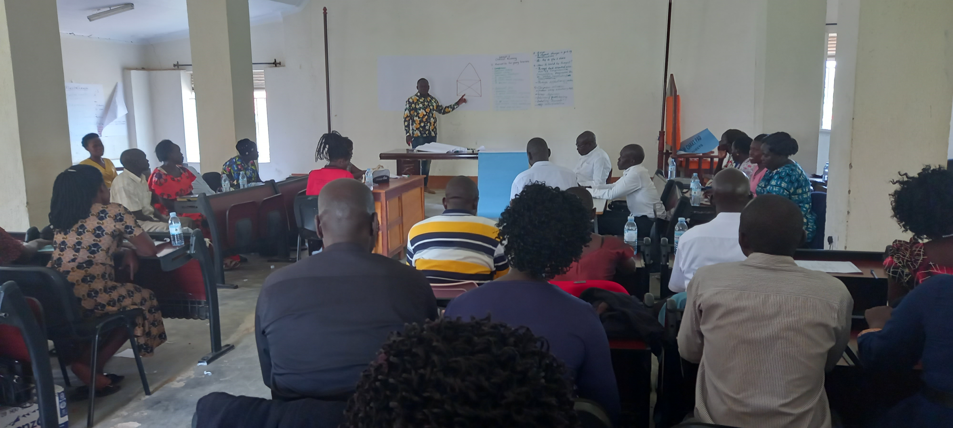
Fig 1: Inception meeting

1113 – Selected teachers trained in Social Emotional learning (SEL) |  | All 10 targeted participants were reached for this activity (6-M, 4F). The one-day activity was conducted at Twajiji Primary School.  The training was objected towards enabling teachers acquire and apply the knowledge, skills, and attitudes to develop healthy identities, manage emotions and achieve personal and collective goals, feel and show empathy for others, establish and maintain supportive relationships, and make responsible and caring decisions while achieving improved psychosocial and mental health wellness.
1113 – Para Counsellors trained in Community Based Psychosocial Support (CBPS) |  | 10 (7-M, 3-F) were reached during the one-day training at Twajiji Primary School. These were selected from the different clusters of the village, with each 0f the 3 clusters having at least three participants.  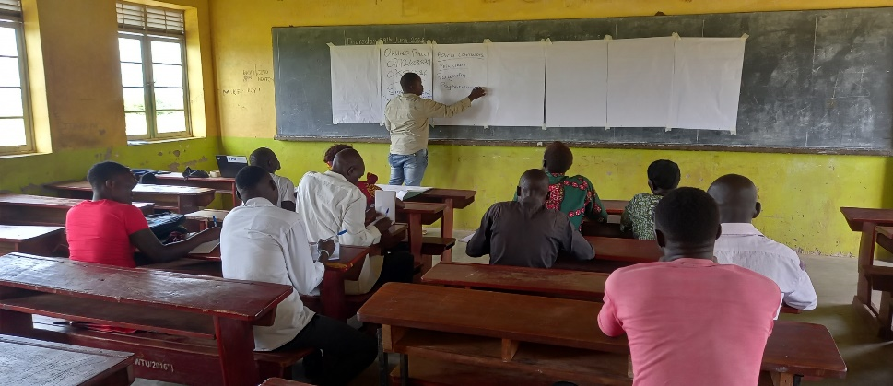  Participants indicated the need to support with visibility material, that would have them easily identified in the community.  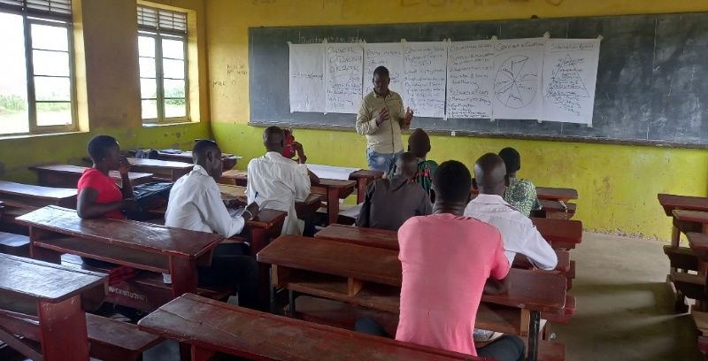
Result/objective 1101 Objective/Phase 2: Increased Abilities of targeted children and youth to cope with social, emotional, and psychological problems through, participating in expressive arts, dance storytelling, stress management skills, conflict management skills, problem-solving skills, , and knowledge of where to seek help or information and resources needed to access care
- identification of project participants through school head teachers, community based paracounsellors, community leaders, and educational partners conducted.  - An integrated five (5) social and emotional learning framework through Community based and arts program is rolled out across the targeted schools and selected 2 blocks in twajiji village |  | 40 (F-19, M=21) Participants in the paraprofessional artistic therapy sessions have been identified through teachers and trained community-based Para Counsellors attached to twajiji village and zone 1. More so, among the 40 participants ,29(F=11, M=18) Children at risk within learning centers and community have already been reached through ongoing sessions for their improved emotional and psychological wellness.  The group Social emotional learning sessions for children at risk involved one or two Para therapists working with a selected small group of children. Groups were designed to target specific problems such as anxiety, depression, attention deficit hyperactivity disorder, post-traumatic stress disorder, trauma and behavioural dysfunction, stress, and emotional self-regulation. Well as other groups within schools took a psychoeducational approach and focused on enhancing awareness and improving social skills, or coping with a range of challenges such as low-self-esteem, emotional regulation, shyness, or a recent loss
 |  | 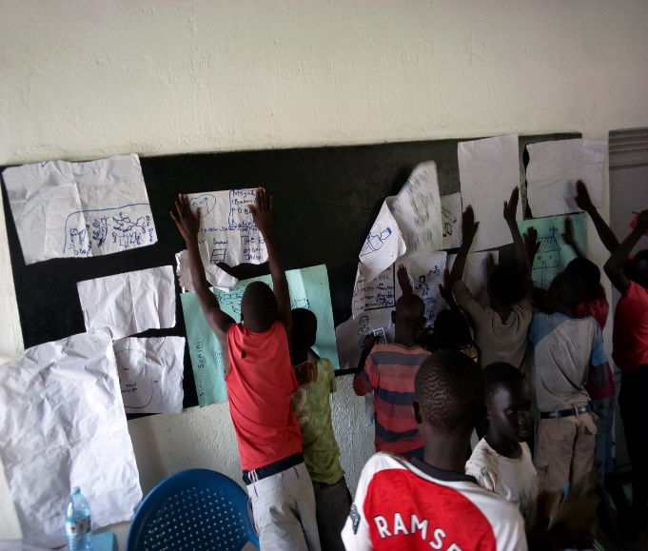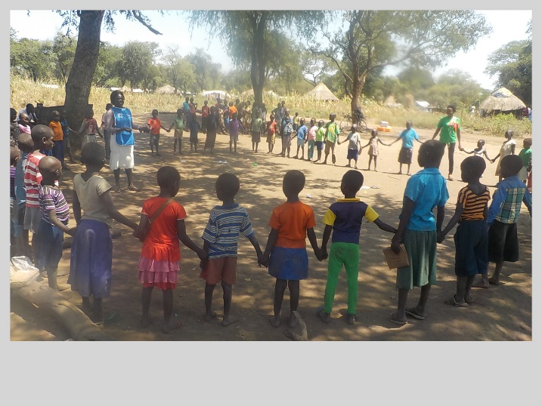
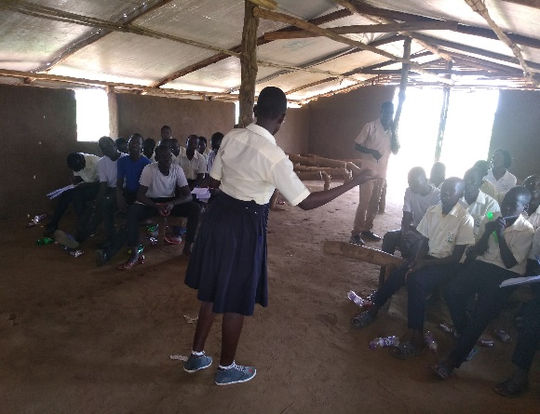
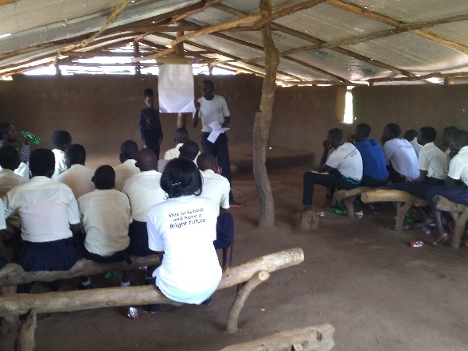
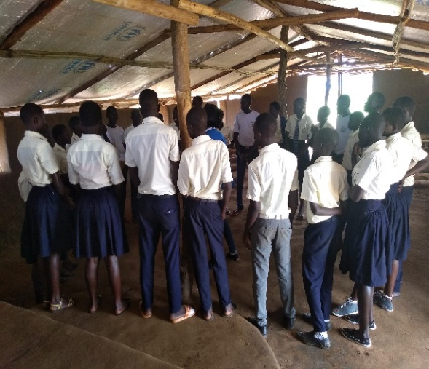
Learners and selected out of school youths engaging in an awareness session on stress management and problem-solving session.
Gender sensitive Expressive arts session are organized and delivered to in various sites in twajji village |  | Through different forms of expressive art mediums, 21(F=9, M=12) children and adolescents identified by trained teachers and community-based Para counsellors and who presented with specific distresses were engaged in creating artwork to facilitate a non-threatening venue process, communicate and receive support in a child friendly and non-intrusive manner. More so through these drawings, our Para counsellors have been able to establish a communication platform with the affected and targeted children which has laid a firm foundation for the follow up sessions as planned.  